EXPERIMENT-6

AIM: To create a simple cloud software application for product selling using any cloud service provider to demonstrate SaaS.

PROCEDURE:
step1: Go to zoho.com.
step 2: Log into the zoho.com.
step 3: Select one application step.
step4: Enter application name as product selling.
step 5: Created new application as product selling.
step 6: Select one form
step 7: The software has been created.
IMPLEMENTATION:
OUTPUT;
1.User Registration
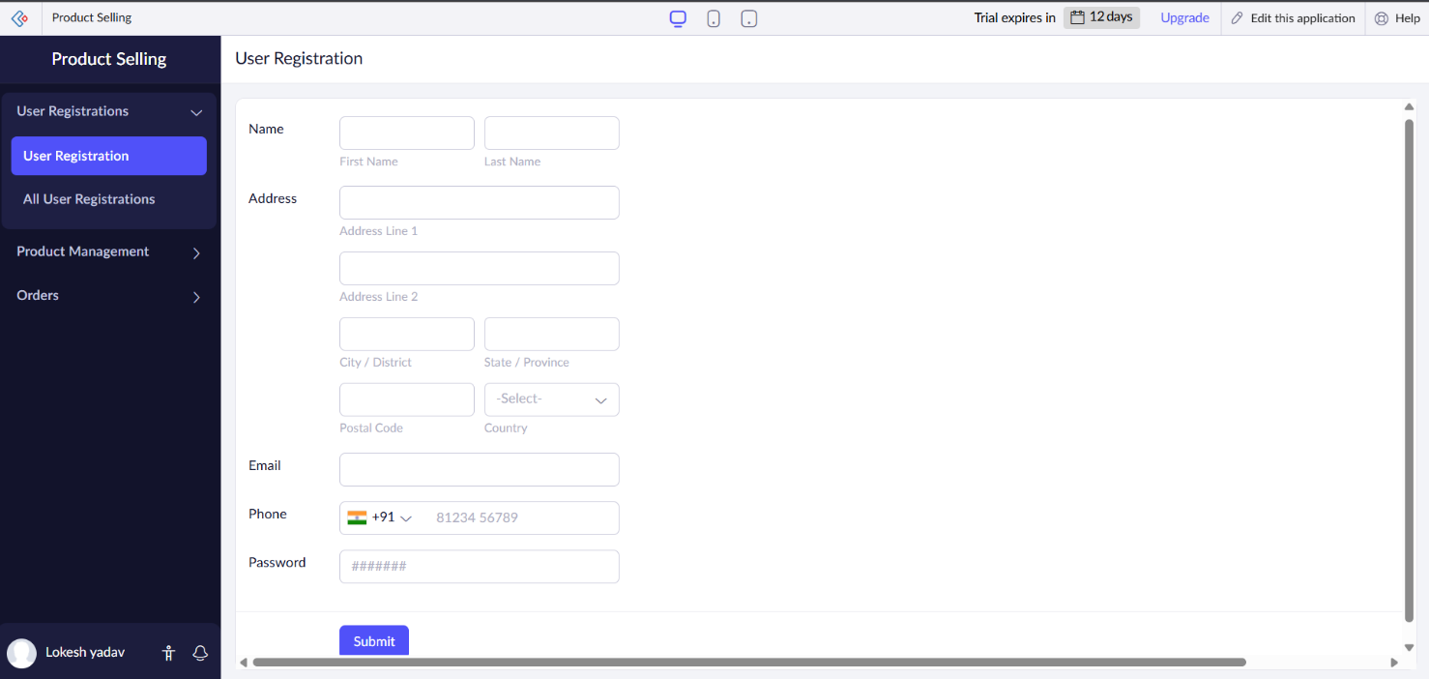

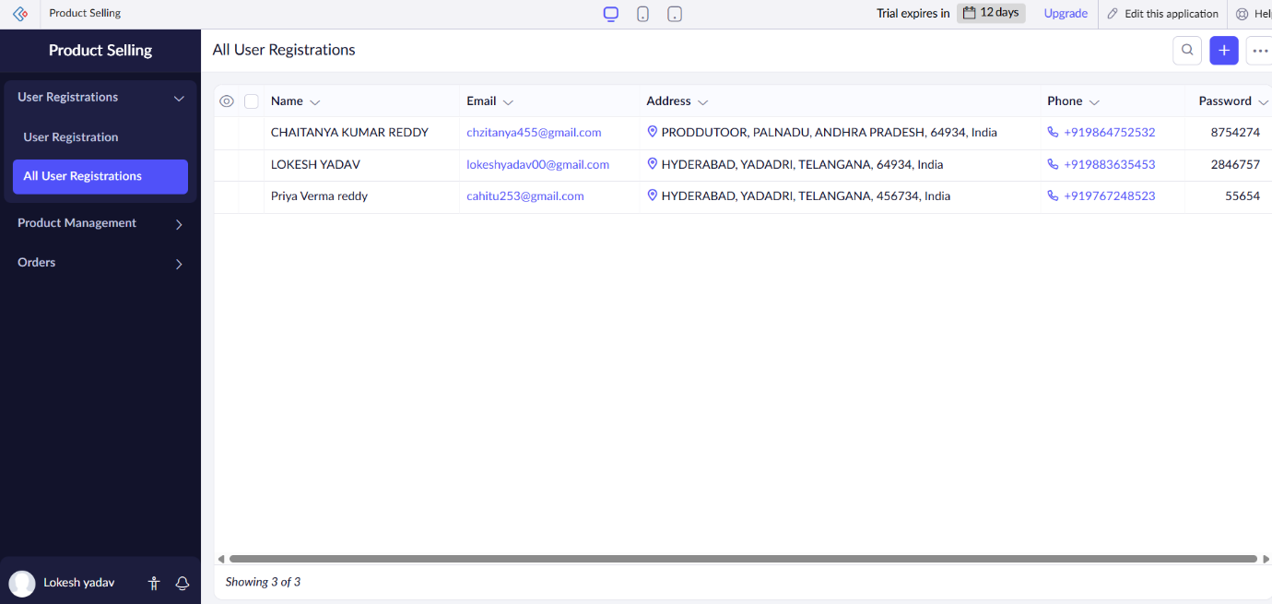

2.Product Management
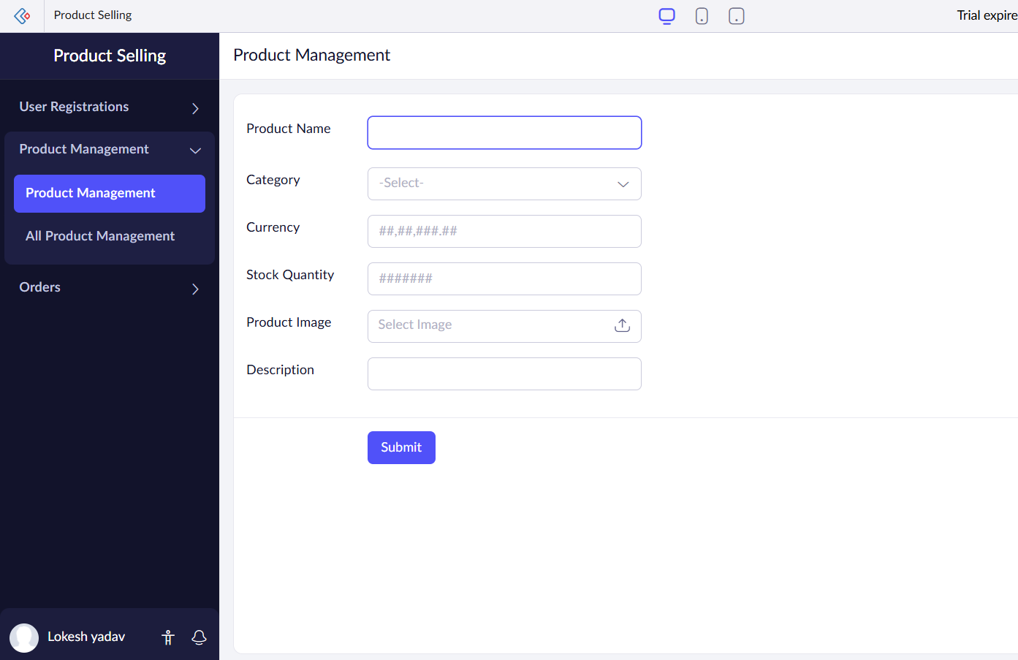

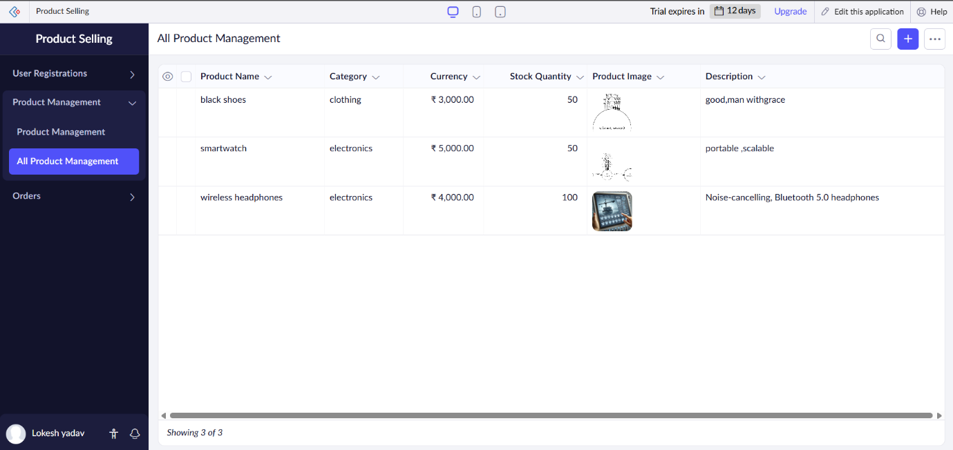

3.Orders

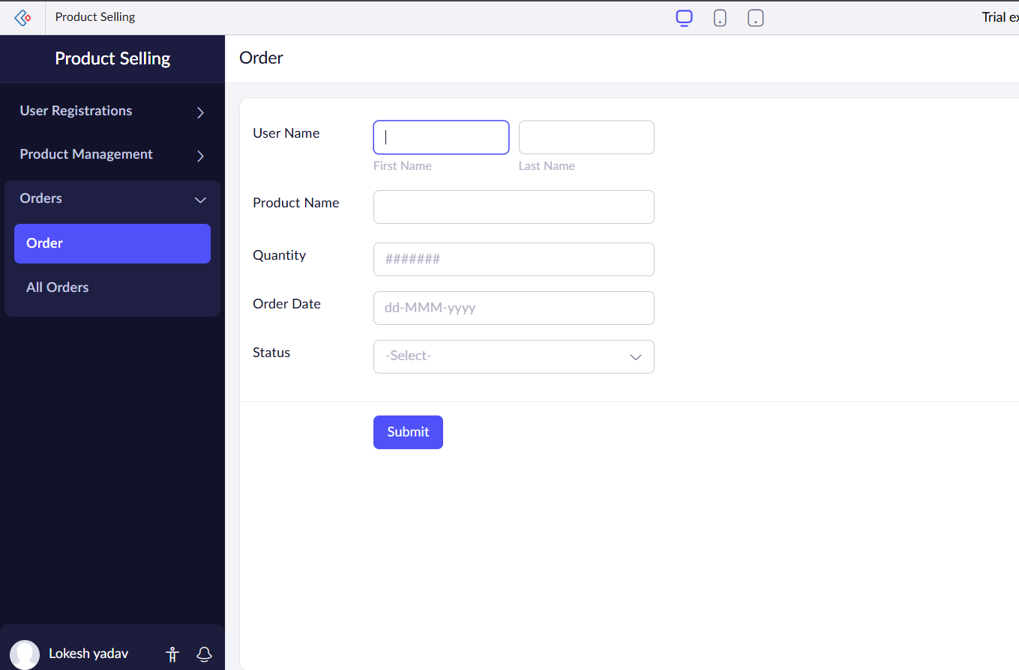

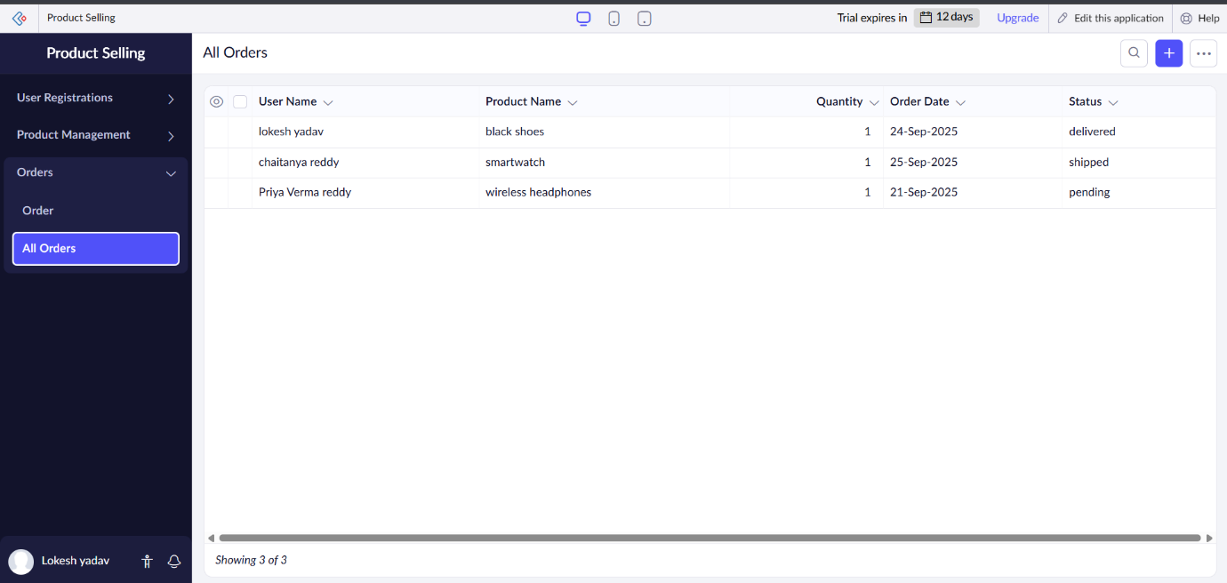

RESULTS; successfully implemented and developed the simple cloud software application for product selling using any cloud service provider to demonstrate SaaS.

